**DETECTING FIRE COMBUSTIN IN FORESTS USING IBM WATSON STUDIO**

**1. INTRODUCTION**

**1.1 Overview**

Forest fires are a major environmental issue, creating economic and ecological damage while endangering human lives. There are typically about 100,000 wildfires in the United States every year. Over 9 million acres of land have been destroyed due to treacherous wildfires. It is difficult to predict and detect Forest Fire in a sparsely populated forest area and it is more difficult if the prediction is done using ground-based methods like Camera or Video-Based approach. Satellites can be an important source of data prior to and also during the Fire due to its reliability and efficiency. The various real-time forest fire detection and prediction approaches, with the goal of informing the local fire authorities.

**1.2 Purpose**

Fire detection systems are designed to discover fires early in their development when time will still be available for the safe evacuation of occupants. Early detection also plays a significant role in protecting the safety of emergency response personnel.

**2. LITERATURE SURVEY**

**2.1 Existing problem**

The most common hazard in forests is forests fire. Forests fires are as old as the forests themselves. They pose a threat not only to the forest wealth but also to the entire regime to fauna and flora seriously disturbing the bio-diversity and the ecology and environment of a region. During summer, when there is no rain for months, the forests become littered with dry senescent leaves and twinges, which could burst into flames ignited by the slightest spark.

**2.2 Proposed solution**

Detection of a fire incident is an efficient way of saving lives and reducing hazards. Forest fires are one of the major environmental concerns, each year millions of hectares are destroyed over the world, causing economic and ecological damage as well as human lives. Thus, predicting such an environmental issue becomes a critical concern to mitigate this threat. Several technologies and new methods have been proposed to predict and detect forest fires. The trend is toward the integration of artificial intelligence to automate the prediction and detection of fire occurrence.

**3. THEORITICAL ANALYSIS**

**3.1 Block Diagram**

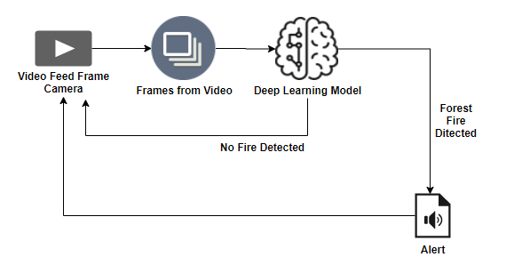

**3.2 Hardware / Software designing**

***Software Requirements:***

* Anaconda Navigator
* Tensor flow
* Keras
* Twilio

***Hardware Requirements:***

* Processor              : Intel Core i3
* Hard Disk Space   : Min 100 GB
* Ram                        : 4 GB
* Display                  : 14.1 “Color Monitor(LCD, CRT or LED)

Clock Speed         : 1.67 GHz

**4. EXPERIMENTAL INVESTIGATIONS**

Study shows that it provide with different test images of a forest fire or normal forest images, the model detects, if there is any forest fire in the video stream. If the forest fire is detected then an alert message will be sent to higher authorities and with a sound, else it returns no danger. For detecting the forest fire we create a twilio account. When the wild fire is detected it will give an alert through a message.

**5. FLOWCHART**

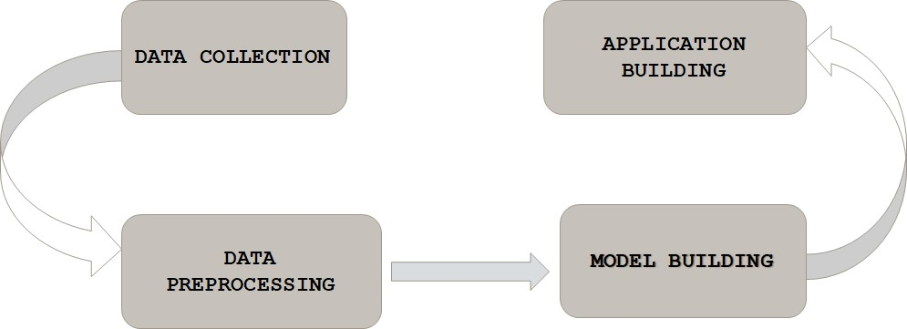

**6. RESULT**

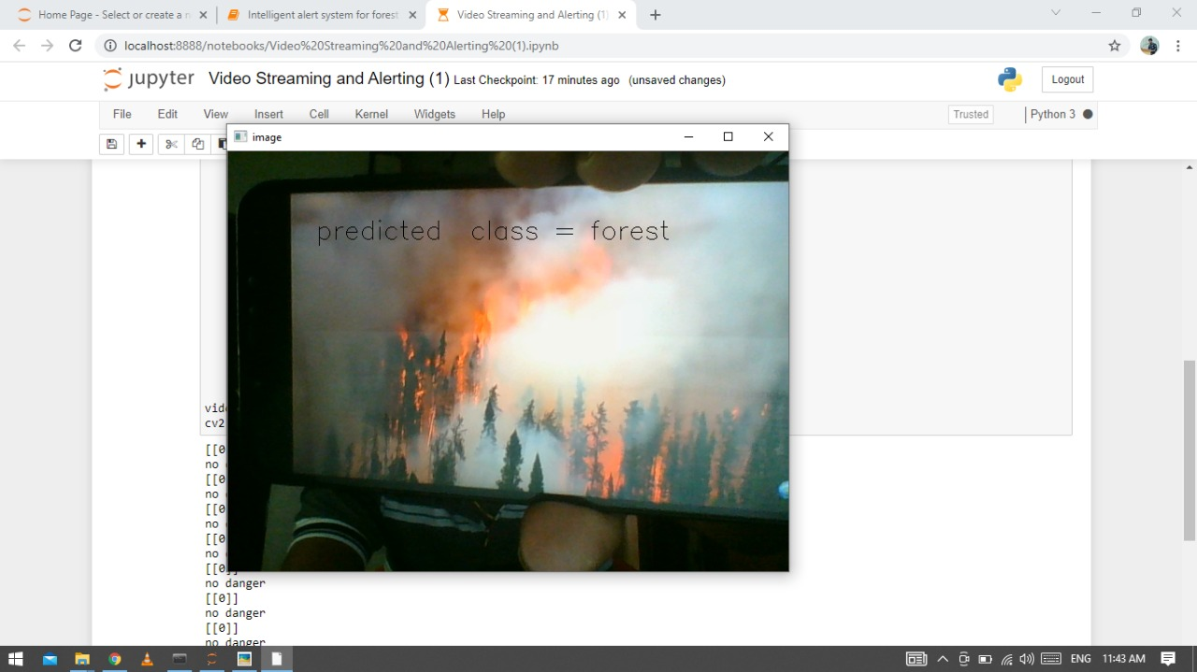



**7. ADVANTAGES & DISADVANTAGES**

***Advantages:***

* Wildfires allow more open spaces for new and different kinds of vegetation to grow and receive sunlight.
* It provides fresh nutrients and shelter for forest plants and animals.
* Wildfires also keep our forests healthy by consuming harmful insects and diseases.

***Disadvantages:***

* Wildfires can destroy homes, lives and millions of acres of forest.
* The aftermath of fire can sometimes be worse than the fire itself.
* Fires burn trees and plants that prevented erosion.
* If the heavy rains occurred after a fire there would be landslides, ash flows, and flash flooding that can damage property and affect the water supply.

**8. APPLICATIONS**

* Wireless Sensor Network (WSN) technology is considered as one of the key technology used in environmental applications, like forest fire detection, agricultural research etc.
* Forest fires in recent years have been devastating both for natural ecosystem, biodiversity and forest economy.
* A wireless sensor network (WSN) based on Internet of Things (IoT) devices and sensors can be used to perform a real-time environmental monitoring of the aforementioned forest fire risk factors.

**9. CONCLUSION**

In this project, we have established the application to detect fire combustion in forests based on the IBM cloud application. Forest fires are a very serious problem in many countries. Millions of hectares of forest are destroyed by fire every year. When the wild fire is detected it will give an alert through a message.

**10. FUTURE SCOPE**

Forest fires can have immediate and long term effects on the quality of rivers, lakes, and streams. The most noticeable impact of wildfires is stormwater runoff. After the loss of vegetation, the ground's soil becomes hydrophobic and prevents the absorption of water.

**11. BIBILOGRAPHY**

* P. M. Hanamaraddi, “A Literature Study on Image Processing for Forest Fire Detection,” *IJITR*, vol. 4, pp. 2695–2700, 2016.
* V. Vipin, “Image processing based forest fire detection,” *International Journal of Emerging Technology and Advanced Engineering*, vol. 2, pp. 87–95, 2012.

**APPENDIX**

**Source Code**

